The goal of this project is to analyze the performance of a softmax-based digit classifier on handwritten digit datasets. We evaluate the model not only using standard accuracy but also through a detailed error analysis and alternative error definitions. Experiments are conducted on both MNIST and USPS datasets.
MNIST Dataset
Training data
- 56000 samples
- size 28*28 pixels
Test data
- 14000 samples
- size 28*28 pixels
Classification model
- Softmax
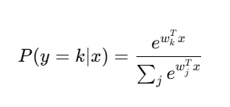
Loss function
- Cross Entropy loss
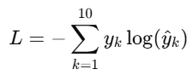
Training algorithm
The parameters were updated using batch gradient descent with a fixed learning rate.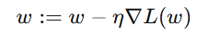
The performance
- Accuracy = 82.31%
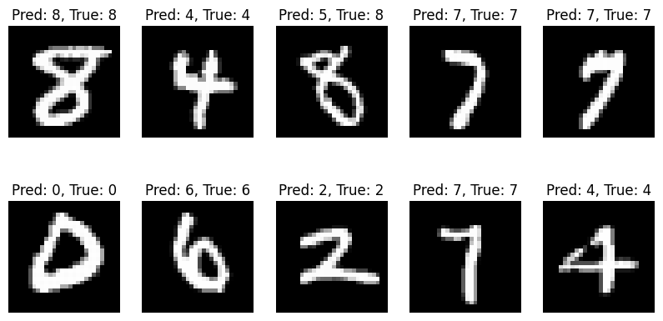
- Confusion Matrix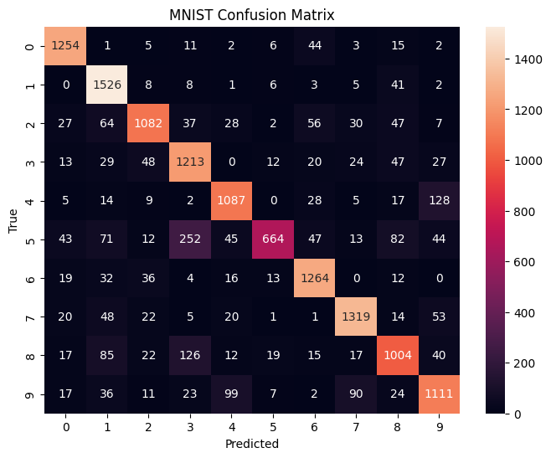
- The types of errors: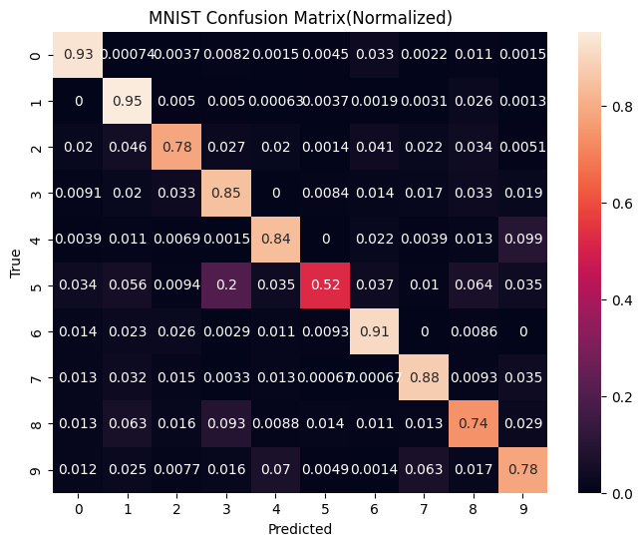
Digit 0: 3.3% were misclassified as 6, and 1.1% as 8.
Digit 1: 2.6% were misclassified as 8.
Digit 2: 4.6% were misclassified as 1, 4.1% as 6, 3.4% as 8, 2.7% as 3, 2.2% as 7, and 2.0% as 0 and 4.
Digit 3: 3.3% were misclassified as 2 and 8, 2.0% as 1, 1.9% as 9, 1.7% as 7, and 1.4% as 6.
Digit 4: 9.9% were misclassified as 9, 2.2% as 6, 1.3% as 8, and 1.1% as 1.
Digit 5: 20.0% were misclassified as 3, 6.4% as 8, 5.6% as 1, 3.7% as 6, 3.5% as 4 and 9, and 3.4% as 0.
Digit 6: 2.6% were misclassified as 2, 2.3% as 1, and 1.4% as 0.
Digit 7: 3.5% were misclassified as 9, 3.2% as 1, 1.5% as 2, and 1.3% as 0 and 4.
Digit 8: 9.3% were misclassified as 3, 6.3% as 1, 2.9% as 9, 1.6% as 2, 1.4% as 5, 1.3% as 0 and 7, and 1.1% as 6.
Digit 9: 7.0% were misclassified as 4, 6.3% as 7, 2.5% as 1, 1.7% as 8, 1.6% as 3, and 1.2% as 0.
- Tolerant accuracy = 84,9%
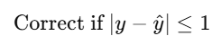

- Some specific example images of the errors
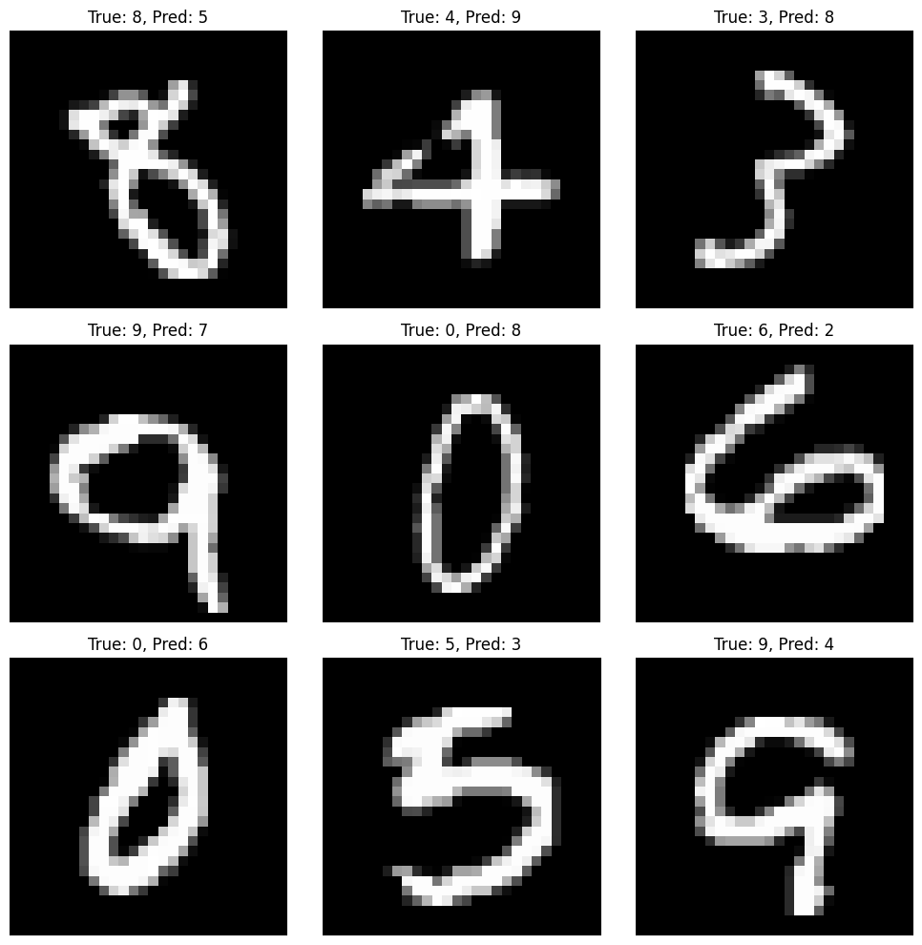
USPS Dataset
Training data
- 7438 samples
- size 16*16 pixels
Test data
- 1860 samples
- size 16*16 pixels
Classification model
- Softmax

Loss function
- Cross Entropy loss

Training algorithm
The parameters were updated using batch gradient descent with a fixed learning rate.
The performance
- Accuracy = 88.66%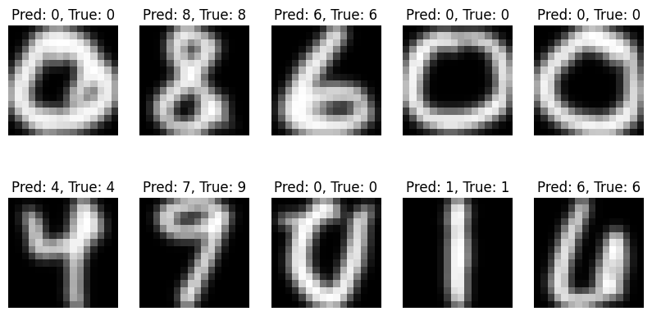

- Confusion Matrix
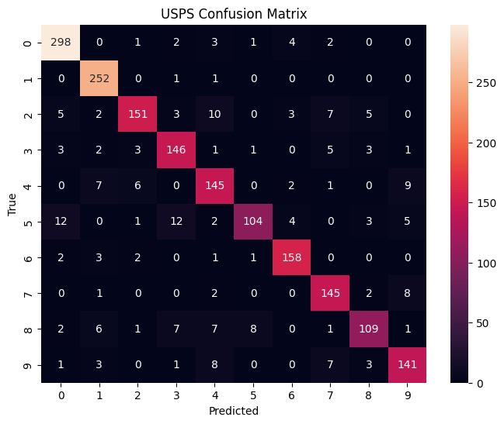
- The types of errors
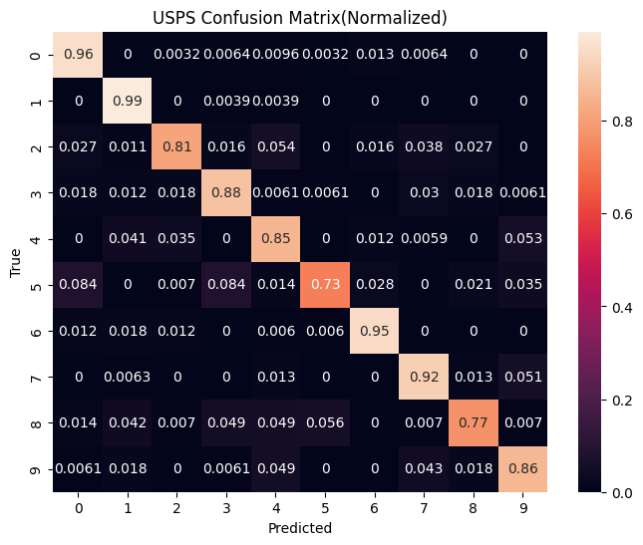

Digit 0: 1.3% were misclassified as 6, and 1% as 4.
Digit 1: 0.4% were misclassified as 3, 0.4% were misclassified as 4.
Digit 2: 2.7% were misclassified as 0, 1.1% as 1, 1.6% as 3, 5.4% as 4, 1.6% as 6, 3.8% as 7, and 2.7% as 8.
Digit 3: 1.8% were misclassified as 0, 1.2% as 1, 1.8% as 2, 3% as 7, and 1.8% as 8.
Digit 4: 4.1% were misclassified as 1, 3.5% as 2, 1.2% as 6, and 5.3% as 9.
Digit 5: 8.4% were misclassified as 0, 8.4% as 3, 1.4% as 4, 2.8% as 6, 2.1% as 8, and 3.5% as 9.
Digit 6: 1.2% were misclassified as 0 and 2, 1.8% as 1.
Digit 7: 1.3% were misclassified as 4 and 8, 5.1% as 9.
Digit 8: 1.4% were misclassified as 0, 4.2% as 1, 4.9% as 4, 5.6% as 5.
Digit 9: 1.8% were misclassified as 1, 4.9% as 7, 4.3% as 7, 1.8% as 8.
- Tolerant accuracy = 84,9%

- Some specific example images of the errors
